Usage Instructions

Lokesh Agnihotri

Version table.
Version | Author | Changes | Date
1.0 | Lokesh Agnihotri | Initial Draft | 27/

Abstract:

This document presents a comprehensive guide aimed at assisting users in the installation of an Integrated Development Environment (IDE), cloning a repository using Git, and launching a Pronunciation Trainer application. The guide begins by providing detailed instructions on downloading and installing PyCharm, a widely used IDE for software development. Users are directed to the official JetBrains PyCharm website, where they can select the appropriate edition and operating system to initiate the installation process. The document then outlines the step-by-step process of cloning a repository from GitHub using Git, highlighting the integration of Git with PyCharm and guiding users through the repository retrieval and project setup. Furthermore, the guide emphasizes the significance of configuring the Python interpreter within PyCharm, explaining how to access the settings menu, select the appropriate interpreter, and manage project dependencies using the integrated terminal. Lastly, the document sheds light on the Pronunciation Trainer application, elucidating its core functionality and purpose in enhancing users' pronunciation skills. Key features, such as speech recognition, audio playback, and interactive exercises, are briefly discussed to provide users with an overview of the application's capabilities. Overall, this professional guide offers users a comprehensive resource to facilitate the seamless installation and utilization of an IDE, repository cloning, and the exploration of a Pronunciation Trainer application.

Contents
Abstract: 1
Downloading the application 2
Downloading the IDE 3
Loading the project in PyCharm and launching it. 4
Setting configuration to Run the flask application. 4
First view of the Pronunciation Trainer 6
Error handling: 8

Downloading the application

To download the application, please follow the professional instructions below:
Open your web browser and go to the GitHub repository for the application: https://github.com/LokeshAgnihotri/pronunciation_trainer_app
Once you're on the GitHub page, locate a green button that says "Code" and click on it. This will open a dropdown menu.
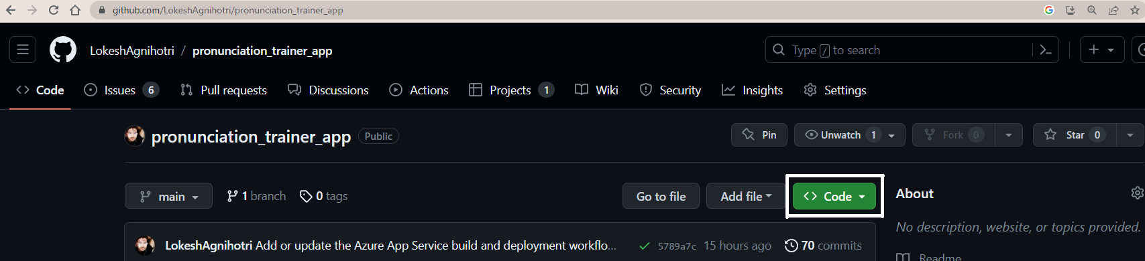
In the dropdown menu, you will see an option labeled "HTTPS." Click on it to display the HTTPS link.
Copy the HTTPS link by clicking the copy icon next to it. This link will be used to clone the repository and download the application.
Before you can clone the repository, you need to have Git installed on your computer. To download Git, go to https://git-scm.com/downloads and follow the instructions specific to your operating system to download and install Git.
Once Git is installed, open the directory on your computer where you want to clone the repository. This is the location where you want to store the application's code.
Open your Git Bash terminal by right-clicking inside the directory and selecting "Git Bash Here" or by navigating to the directory using the command line and typing "git bash" into the command prompt.
In the Git Bash terminal, type the following command: git clone [paste the copied HTTPS link] (without the brackets). This command will initiate the cloning process and download all the code for the application into the chosen directory.
Wait for the cloning process to complete. Once it's finished, you will have successfully downloaded the application's code from the GitHub repository.
You now have the application's code available in your chosen directory. You can proceed with further steps to set up and run the application as per the instructions provided with the code, such as installing any dependencies or configuring the environment.

Downloading the IDE

Recommended IDE for this project is PyCharm, but you can also use anyone else of your choice.
here are the steps to download PyCharm:
To download PyCharm, a popular integrated development environment (IDE) for Python, follow these steps:
Visit the JetBrains PyCharm website: Open your web browser and navigate to the official JetBrains PyCharm website at https://www.jetbrains.com/pycharm/.
Choose the edition: On the PyCharm website, you'll find different editions available. There is a Community Edition (free) and a Professional Edition (paid). Select the edition that best suits your needs.

Click on "Download": Once you've chosen the edition, click on the "Download" button for that edition. It will typically be displayed prominently on the website.
Select your operating system: After clicking "Download," you will be directed to a page where you can select your operating system. Choose the appropriate option for your computer, such as Windows, macOS, or Linux.
Choose the version: On the download page, you may have the option to choose between the latest stable version and an older version. It's usually recommended to download the latest stable version, unless you have a specific reason to use an older version.
Download the installer: Once you've selected your operating system and version, click on the download button or link to start downloading the PyCharm installer file. The file size may vary depending on the edition and version you selected.
Run the installer: After the download is complete, locate the downloaded file on your computer and run the installer by double-clicking on it. This will start the installation process.
Follow the installation wizard: The installation wizard will guide you through the installation process. You may be asked to select the installation location, agree to the terms of service, and choose any additional components or settings. Follow the on-screen instructions and make selections according to your preferences.
Wait for the installation to complete: Once you've made all the necessary selections in the installation wizard, click on the "Install" or "Next" button to start the installation process. Wait for the installer to complete the installation of PyCharm on your computer.
Launch PyCharm: Once the installation is finished, you can launch PyCharm by finding it in your applications menu (on macOS and Linux) or through the Start menu (on Windows). Click on the PyCharm icon to open the IDE.

Loading the project in PyCharm and launching it.

Open PyCharm: Launch PyCharm on your computer by finding it in your applications menu (on macOS and Linux) or through the Start menu (on Windows).
Open the project: In PyCharm, click on "Open" or select "Open" from the welcome screen. Navigate to the directory where you have downloaded the project from GitHub and select the project folder. Click on "Open" to open the project in PyCharm.
Configure Python interpreter: PyCharm needs to know which Python interpreter to use for the project. Go to File -> Settings (or PyCharm -> Preferences on macOS), then navigate to Project -> Python Interpreter. Click on the gear icon and select "Add" to add a new interpreter. Choose the desired Python interpreter and click on "OK" to set it up.
Install project dependencies: If the project requires external libraries or dependencies, you need to install them. PyCharm provides an integrated terminal to execute commands. Open the terminal within PyCharm by going to View -> Tool Windows -> Terminal. In the terminal, navigate to the root directory of the project where the requirements.txt file is located. Use the command pip install -r requirements.txt to install the dependencies listed in the file.
You can also download and install the dependencies by clicking on Python packages and then install as shown in image below:
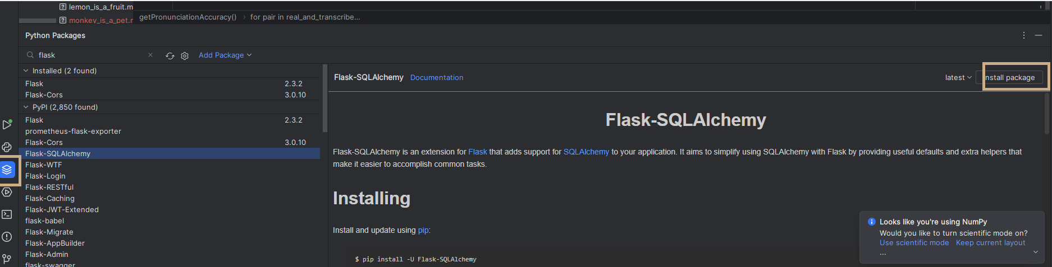

Verify project setup: Once the dependencies are installed, verify that the project is set up correctly. You can navigate through the project files and open the main file or entry point to ensure everything is working as expected.

Setting configuration to Run the flask application.

Open your Flask project in PyCharm: Launch PyCharm and open the project directory containing your Flask application.
Configure a new Run Configuration: Go to the top toolbar and click on "Run" to open the Run/Debug Configurations menu. Click on the "+ Add Configuration" button (or the "Edit Configurations..." option) to create a new configuration.

Select the Flask configuration: In the Run/Debug Configurations menu, click on the "+ Add Configuration" button (or the "+ Alt+Insert" shortcut). From the list of available configurations, choose "Flask".
Specify the Flask app script: In the Flask configuration settings, provide the path to the main script of your Flask application. This is usually the script file that contains the app object creation or initialization. In the "Script" field, click on the folder icon and navigate to the appropriate file. In our case app.py
Set up the Python interpreter: In the Flask configuration settings, ensure that the correct Python interpreter is selected for your project. Click on the "..." button next to the "Python interpreter" field and choose the desired interpreter from the list.
Save the configuration: Click on the "OK" button to save the Flask configuration.
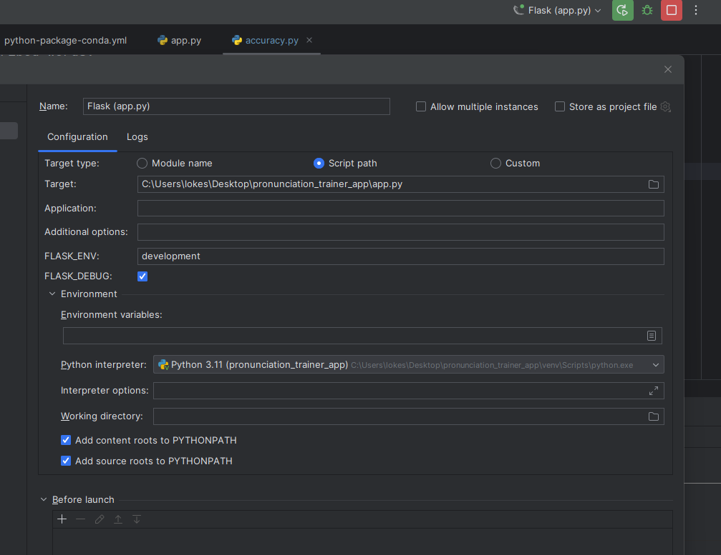

Run the Flask app: In the top toolbar, select the Flask configuration you just created from the dropdown menu of available configurations. Then click on the "Run" button (or press Shift+F10) to start running your Flask app.
Verify the Flask app: Once the Flask app is running, open your web browser and enter the specified host and port in the address bar (e.g., http://localhost:5000). You should be able to see your Flask application running.

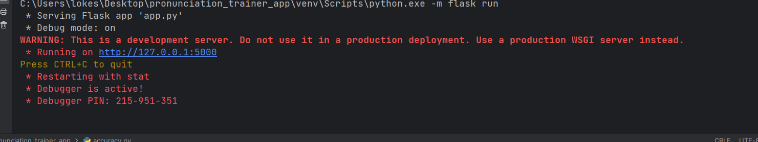

Pronunciation Trainer
Upon launching the application, users are greeted with the initial view:
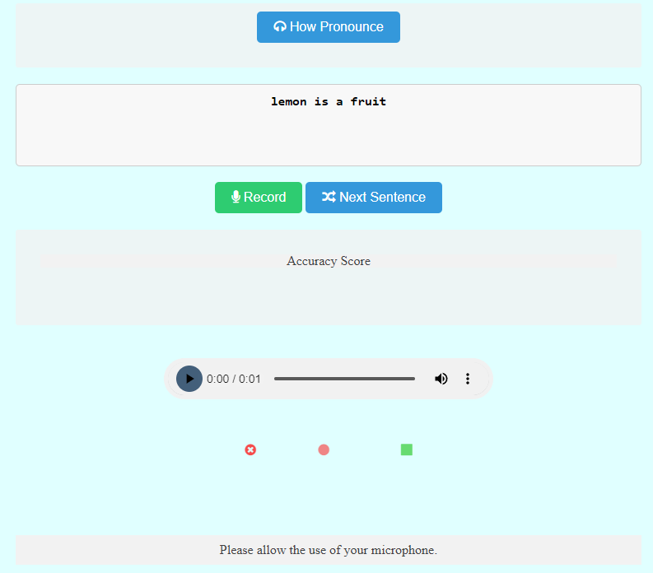
The application interface displays a Textbox pre-filled with a text that the user is required to pronounce. To obtain the correct phonetics and pronunciation, users can click on the "How Pronounce" Button. Upon clicking, the text in the Textbox is transformed into its phonetic representation, complete with accurate accent and pronunciation. Additionally, an audio sample is played, providing a clear demonstration of how the sentence should be spoken.
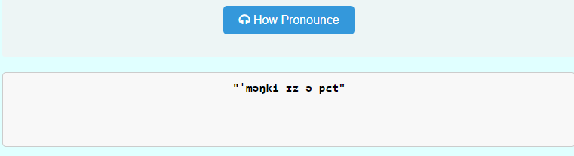
Users can utilize the play button to listen to the recording multiple times, allowing them to grasp the desired pronunciation. The play button can be clicked as frequently as desired until the user feels satisfied and comprehends the correct pronunciation.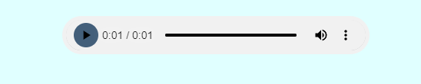
To engage in pronunciation practice, users can proceed by clicking on the record button. This initiates a timer, displaying the recording duration, along with options to either cancel the recording (X) or complete and stop it. Should the user choose to cancel the recording, they can utilize the play button to listen to the recording again, facilitating further practice.

Alternatively, if the user opts to click the stop button, the recording undergoes analysis, and an accuracy score is provided, which is then updated in the designated box.

In addition to the accuracy score, users are presented with visual feedback indicating any mispronunciations. Correctly pronounced words are highlighted in green, moderately accurate pronunciations are depicted in orange (50-60% accuracy), and poorly pronounced words are marked in red.
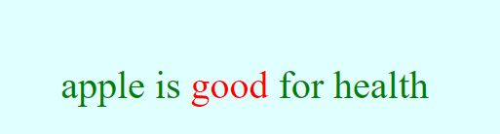
Upon receiving visual and accuracy feedback, users can listen to the correct pronunciation again and utilize the record button to further improve their accuracy. Subsequently, users can click on the "Next Sentence" button to practice a new sentence, thus progressing through the learning process.

Points to remember.
Make sure to allow microphone access to the app to enable recording.
Make sure that you are in a noise proof and in a silent environment for best accuracy.
To add more sentences to practice you can add them in the ‘dictionary.txt’ file.

